Викладач англійської мови
ЛВПУТТС НТУ
Пилипчук Оксана Богданівна

Тема уроку: Подорожі. Мій улюблений вид подорожі.
Travelling. My favourite kind of travelling, my favourite
kind of transport.

Мета уроку: навчити учнів використовувати вивчену лексику в різних ситуаціях; навчити учнів виявляти переваги і недоліки подорожей різними видами транспорту; вчити висловлювати свою думку, розширити знання учнів з теми. Розвивати комунікативні здібності учнів, навички читання, усного мовлення, критичне мислення. Виховувати самостійність, комунікабельність і культуру поведінки в громадських місцях.
Обладнання: роздатковий матеріал: тексти, завдання для груп, малюнки до
теми; підручник, словник
Метод навчання та форми роботи: розповідь з елементами бесіди,
індивідальна робота, робота в групах
Тип уроку: комбінований
Міжпредметні зв’язки: географія, спеціальна технологія

Хід уроку

І. Введення в іншомовне середовище.
1. Організаціна частина.
T. Good morning.
What date is it today?
Who is absent?
I hope that our co-operation will be successful. I want to ask you to be attentive and active. Speak and express your opinion. So, let’s start our communication.
2. Introducting of the topic. Aim.
Повідомлення теми і мети уроку.
Look at the blackboard, read the saying and try to guess the theme of our lesson.

“The world is a book, and those who do not travel, read only a page”
(St.Augustine)

T. You are right the topic of our today’s lesson is “Travelling. My favourite kind of travelling, my favourite kind of transport. How would you like to travel?» Today we’ll do different tasks. As we have already learned many words and about different ways of travelling you can show and use your knowledge.
3. Warm-up.
1) Фонетична зарядка.
Let’s read this short rhyme and practice some sounds: [w], [t].
We go by car We go by land
And we go by train. And sea and air
We go by boat We go, go, go
And we go by plane. From here to therе
2) Мовленнєва зарядка.
a)Modern life is impossible without travelling. Tell me, please: How do you understand the word Travelling?
(Ps. give answers)
b) T: What brunches does it consist of?
(Ps.: Travelling by air, by water, by land.)
с) T: What are the means of travelling by air, water, land?
(Ps.: -by plane, by spaceship, by rocket;
-by ship, by boat, by canoe;
-by car, by bus, by train;
d) Why do people travel? What makes them travel?
(Ps,: People travel because they want to visit new countries.
They often travel on business.
We travel to get new impressions.
They travel to meet new friends.
My cousin travels to study at a university.
Some people travel to earn much money.
We travel to visit our relatives.)

II. Основна частина уроку.
- Активізація знань лексики.
Відгадування загадок.
Let’s guess the riddles.T. To check your knowledge about the kinds of transport.

This is a house on wheels is running a race,
Taking people from place to place.(A bus)

When it is driven it goes,
When it stops, it falls down. (A bike)

What is it? That has no wheels
And leaves no tracks on the water behind it? (A boat)

Through not a bird, not a butterfly,
I can fly high up in the sky. (A plane)

T. Great. You're very smart. You've guessed everything.
2.) Reading. Groupwork. Читання тексту.
Робота в групах.
Let’s divided into groups.

- Read the text.
Travelling by plane is the fastest. You can get to many cities only in a few hours. You can not stop wherever you like. During the trip you can sit comfortably in the armchair and read, eat or sleep. During the trip you need tickets.
People can visit many countries by plane. When the weather is rainy or foggy you can not travel by it.

Hiking is interesting and it is also good for health. This way of travelling is not the fastest. You can visit many interesting places. It helps to learn many interesting things and enjoy beautiful places. You don’t need to think about the tickets and timetable. Hiking helps physical training.
Travelling by train is rather fast and not so expensive. When you are going by train you can sit comfortably in your carriage. You can not stop wherever you like. You can read and sleep. For this way of travelling you need tickets. It is good for your health. You can see the country you are travelling through and not only the clouds as you are flying.
- Work in groups.

T: Write advantages and disadvantages of travelling:
By train, by air, on foot
advantages disadvantages
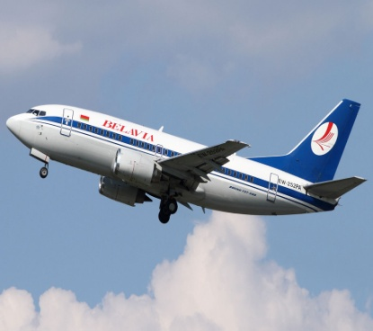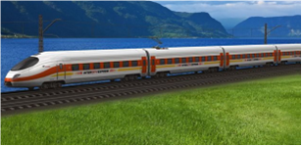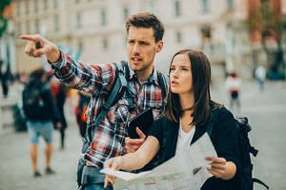

- Your attitude to the travelling.
T: How would you like or would not like to travel?

III. Заключна частина уроку.
T.: Now we’ll sum up our lesson
1.) Підведення підсумків уроку. Thank you for your hard work at the lesson. I should say you worked well and were very active.

Your mark is….

2.) Домашнє завдання. Homework.
Your home task is to describe your favorite way of travelling.
The lesson is over
Good bye.

Список використаних джерел

- Коваленко О. Інновації у вивченні іноземної мови / О. Коваленко // English. – 2005. – №36 (276). – С. 4-5.
- Спілкуємося англійською мовою/ За ред. П.Корнеса і Н.Гайдук. – Львів: СП «БаК», 1998.
- Мансі Є.О.English: Фонетика, граматика, тексти, діалоги, розмовні теми. Підручник. Для студентів немовних факультетів вищих навчальних закладів. –К.: Видавничий центр «Академія», 2004.
- Погарська Т.В. Англійська мова. 11 клас. Плани-конспекти уроків. – Харків: Веста: Видавництво «Ранок», 2001.
- Плахотник В.М., Мартинова Р.Ю. Англійська мова: Підручник для 11 кл. серед. шк. – 2-ге вид. – К.: Освіта, 2000.

